**BANK LOAN REPORT QUERY DOCUMENT**

**KPI’s:**

**Total Loan Applications**

SELECT COUNT(id) AS Total_number_of_Loan_Application FROM Bank_Loan



**MTD Loan Applications**

SELECT COUNT(id) AS Total_MTD_number_of_Loan_Application FROM Bank_Loan Where MONTH(issue_date) = 12 and YEAR(issue_date) = 2021



**PMTD Loan Applications**

SELECT COUNT(id) AS Total_PMTD_number_of_Loan_Application FROM Bank_Loan Where MONTH(issue_date) = 11 and YEAR(issue_date) = 2021



Month to Month Percentage =( Total_MTD_number_of_Loan_Application- Total_PMTD_number_of_Loan_Application)/ Total_PMTD_number_of_Loan_Application

=(4314-4035)/4035

**Total Funded Amount**

SELECT SUM(loan_amount) AS Total_Funded_Amount FROM Bank_Loan



**MTD Total Funded Amount**

SELECT SUM(loan_amount) AS MTD_Total_Funded_Amount FROM Bank_Loan WHERE MONTH(issue_date) = 12 AND YEAR(issue_date) = 2021



**PMTD Total Funded Amount**

SELECT SUM(loan_amount) AS PMTD_Total_Funded_Amount FROM Bank_Loan WHERE MONTH(issue_date) = 11 AND YEAR(issue_date) = 2021

Month To Month percentage =( MTD_Total_Funded_Amount- PMTD_Total_Funded_Amount)/ PMTD_Total_Funded_Amount

=(53981425-47754825)/47754825

**Total Amount Received**

SELECT SUM(total_payment) AS Total_Payment_Received FROM Bank_Loan



**MTD Total Amount Received**

SELECT SUM(total_payment) AS MTD_Total_Payment_Received FROM Bank_Loan WHERE MONTH(issue_date) = 12 AND YEAR(issue_date) = 2021



**PMTD Total Amount Received**

SELECT SUM(total_payment) AS PMTD_Total_Payment_Received FROM Bank_Loan WHERE MONTH(issue_date) = 11 AND YEAR(issue_date) = 2021



Month on Month Percentage = (MTD_Total_Payment_Received - PMTD_Total_Payment_Received)/ PMTD_Total_Payment_Received

= (58074380-50132030)/50132030

**Average Interest Rate**

SELECT Round(AVG(int_rate),4)*100 AS Avg_Interest_Rate FROM Bank_Loan



**MTD Average Interest**

SELECT Round(AVG(int_rate),4)*100 AS MTD_Avg_Interest_Rate FROM Bank_Loan WHERE MONTH(issue_date) = 12 AND YEAR(issue_date) = 2021



**PMTD Average Interest**

SELECT Round(AVG(int_rate),4)*100 AS PMTD_Avg_Interest_Rate FROM Bank_Loan WHERE MONTH(issue_date) = 11 AND YEAR(issue_date) = 2021



Month on month change = (MTD_Avg_Interest_Rate - PMTD_Avg_Interest_Rate)/ PMTD_Avg_Interest_Rate

= (12.36-11.94)/11.94

**Avg DTI**

SELECT ROUND(AVG(dti),4)*100 AS Avg_DTI FROM Bank_Loan



**MTD Avg DTI**

SELECT ROUND(AVG(dti),4)*100 AS MTD_Avg_DTI FROM Bank_Loan WHERE MONTH(issue_date) = 12 AND YEAR(issue_date) = 2021



**PMTD Avg DTI**

SELECT ROUND(AVG(dti),4)*100 AS PMTD_Avg_DTI FROM Bank_Loan WHERE MONTH(issue_date) = 11 AND YEAR(issue_date) = 2021



Month on Month Change on DTI = (MTD_Avg_DTI - PMTD_Avg_DTI)/ PMTD_Avg_DTI

= (13.67-13.3)/13.3

**Loan** **Status**

SELECT distinct(loan_status) FROM Bank_Loan

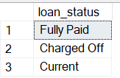

**GOOD LOAN ISSUED**

**Good Loan Percentage**

SELECT

(COUNT(CASE WHEN loan_status = 'Fully Paid' OR loan_status = 'Current' THEN id END)*100.0)

/

COUNT(id) AS Good_Loan_Percentage

FROM Bank_Loan



**Good Loan Applications**

SELECT COUNT(id) AS Total_Number_of_Good_Loan FROM Bank_Loan WHERE loan_status = 'Fully Paid' OR loan_status ='Current'



**Good Loan Funded Amount**

SELECT SUM(loan_amount) AS Total_Amount_Funded_for_Good_Loan FROM Bank_Loan WHERE loan_status ='Fully Paid' OR loan_status = 'Current'



**Good Loan Amount Received**

SELECT SUM(total_payment) AS Total_Amount_Received_from_Good_Loan FROM Bank_Loan WHERE loan_status ='Fully Paid' OR loan_status = 'Current'



**BAD LOAN ISSUED**

**Bad Loan Percentage**

SELECT

(COUNT(CASE WHEN loan_status ='Charged Off' THEN id END)*100.0)

/

COUNT(id) AS Bad_Loan_Percentage

FROM Bank_Loan



**Bad Loan Applications**

SELECT COUNT(id) AS Total_Number_of_Bad_Loan FROM Bank_Loan WHERE loan_status = 'Charged off'



**Bad Loan Funded Amount**

SELECT SUM(loan_amount) As Total_Amount_Funded_for_Bad_Loan FROM Bank_Loan WHERE loan_status = 'Charged Off'



**Bad Loan Amount Received**

****SELECT SUM(total_payment) As Total_Amount_Recovered_from_Bad_Loan FROM Bank_Loan WHERE loan_status = 'Charged Off'

**LOAN STATUS**

SELECT

loan_status,

COUNT(id) AS Total_Number_of_Loans,

SUM(loan_amount) AS Total_Funded_Amount,

SUM(total_payment) AS Total_Amount_Recovered,

ROUND(AVG(int_rate*100),2) AS Avg_Rate_of_Interest,

ROUND(AVG(dti*100),2) As Avg_DTI

FROM Bank_Loan

GROUP BY loan_status

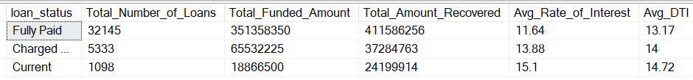

SELECT

loan_status,

SUM(loan_amount) AS MTD_Funded_Amount,

SUM(total_payment) AS MTD_Recovered_Amount

FROM Bank_Loan

WHERE MONTH(issue_date) = 12 AND YEAR(issue_date) = 2021

GROUP BY loan_status

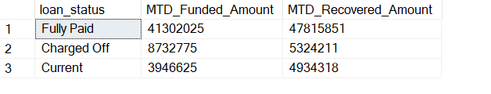

1. **BANK LOAN REPORT | OVERVIEW**

**MONTH**

SELECT

MONTH(issue_date) AS Month_Number,

DATENAME(MONTH, issue_date) AS Month_Name,

COUNT(id) AS Total_Number_of_Loan,

SUM(loan_amount) AS Total_Funded_Amount,

SUM(total_payment) As Total_Recovered_Amount

FROM Bank_Loan

GROUP BY MONTH(issue_date) , DATENAME(MONTH, issue_date)

ORDER BY MONTH(issue_date)

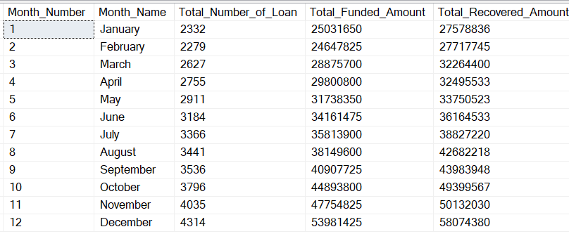

**STATE**

SELECT

address_state,

COUNT(id) AS Total_Number_of_Loan,

SUM(loan_amount) AS Total_Funded_Amount,

SUM(total_payment) As Total_Recovered_Amount

FROM Bank_Loan

GROUP BY address_state

ORDER BY address_state

--( WE can also use these arguments to sort data -- ORDER BY Total_Funded_Amount DESC, ORDER BY Total_Number_of_Loan DESC)--

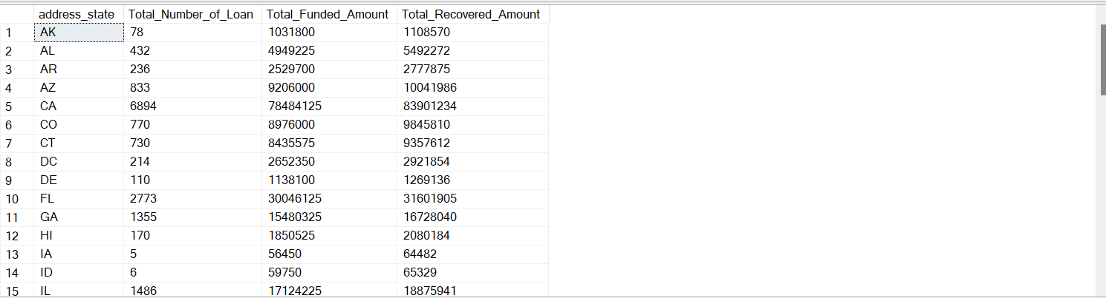

**TERM**

SELECT

term AS Term,

COUNT(id) AS Total_Number_of_Loan,

SUM(loan_amount) AS Total_Funded_Amount,

SUM(total_payment) As Total_Recovered_Amount

FROM Bank_Loan

GROUP BY term

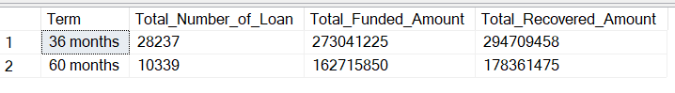ORDER BY term

**EMPLOYEE LENGTH**

SELECT

emp_length AS Service_Length,

COUNT(id) AS Total_Number_of_Loan,

SUM(loan_amount) AS Total_Funded_Amount,

SUM(total_payment) As Total_Recovered_Amount

FROM Bank_Loan

GROUP BY emp_length

ORDER BY emp_length

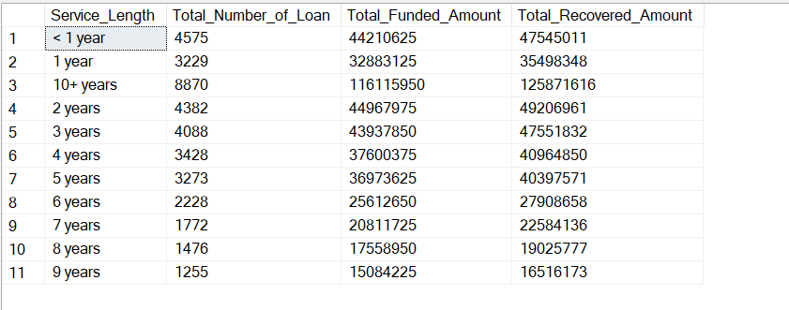

**PURPOSE**

SELECT

purpose AS Purpose_of_Loan,

COUNT(id) AS Total_Number_of_Loan,

SUM(loan_amount) AS Total_Funded_Amount,

SUM(total_payment) As Total_Recovered_Amount

FROM Bank_Loan

GROUP BY purpose

ORDER BY purpose

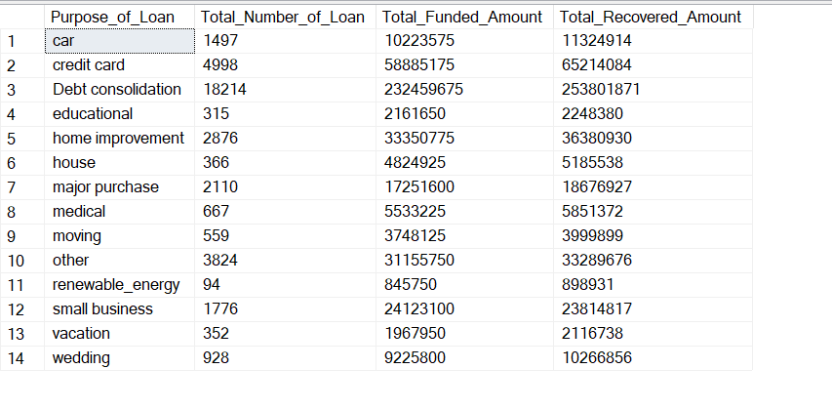

**HOME OWNERSHIP**

SELECT

home_ownership AS Type_of_Home_Ownership,

COUNT(id) AS Total_Number_of_Loan,

SUM(loan_amount) AS Total_Funded_Amount,

SUM(total_payment) As Total_Recovered_Amount

FROM Bank_Loan

GROUP BY home_ownership

ORDER BY home_ownership

